Architectural-Design
Version: Refer to the version in the file name

Contents
1 Data Storage 1
2 Local Data 1
3 Model 1
3.1 Classes 1
3.1.1 Person 2
3.1.2 Enum BloodType 2
3.1.3 Patient (extends Person) 2
4 Heading-3 Error! Bookmark not defined.
4.1 Heading-3.1 Error! Bookmark not defined.

Data Storage
Client-Server Architecture
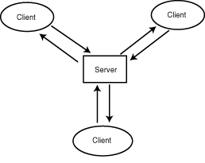

Local Architecture
MVC Architecuture
 | Description
Model | Actual programming logic; what the program actually does
View | Renders data for user to see
Controller | Translates user actions into operations on Model

Model

Classes
Lists the classes required for MentCare

Person
- Variables (private)
  - lastName, firstName, DOB, email, phoneNumber
- Constructors
  - Public Person(lastName, firstName)
    - Assigns name values
  - “”(lastName, firstName, email)
    - Assigns name values and email
  - “”(lastName, firstName, email, phoneNumber)
    - Assigns names, email, and phoneNumber)
  - “”(lastName, firstName, email, phoneNumber, DOB)
    - Assigns all values
- Setters
- Getters
- Manipulators

Enum BloodType
Lists blood types as enums because blood types are static. This also prevents user from entering a value that is an invalid blood type.

Patient (extends Person)
- Variables
  - String bloodType, SSN, condition(s), treatment(s)
- Constructors
- Setters
- Getters
- Manipulators

